- Wipe liquid in the lyophilizer chamber out with paper towel
- Turn on lyophilizer (black switch bottom left side)
- Press “man” and wait ~20 minutes for the temperature to drop below -40°C
- Make sure lid is secured and turn on vacuum pump (Right side) and press “vacuum” on the Lyophilizer.
- Put samples in Speedvac and balanced the tubes (make sure to leave ependorff lids open)
- Turn on Speedvac Rotor and turn the flat side of the lyophilizer valve to face towards the tube.
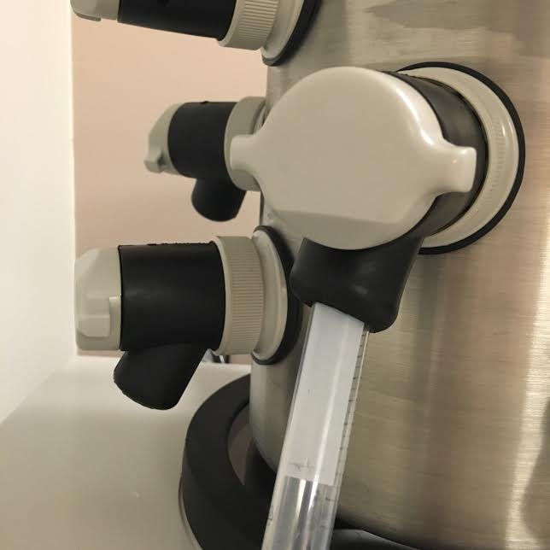

- Watch to make sure the Torr decreases to indicate vacuum is working.
- To check if sample is dry, turn lyophilizer valve so it matches with the circle and releases the vacuum. The pump leaves on
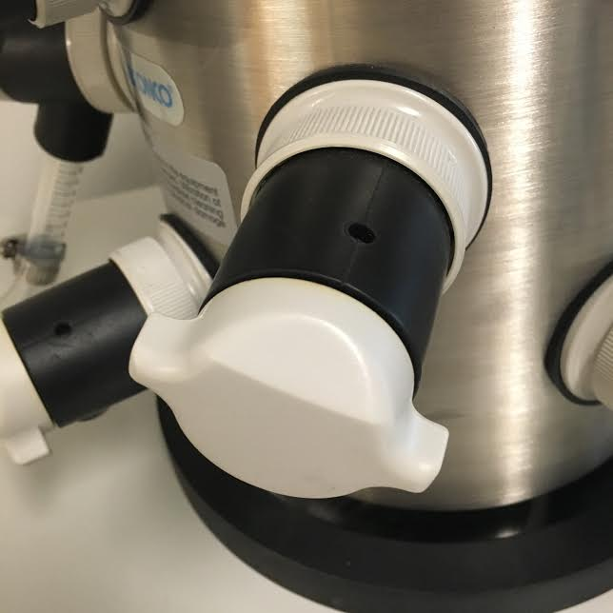

- Turn off Speedvac rotor and wait until it’s at a complete stop before opening Speedvac. If not dried, put in to continue to dry. If not dry for more than one hour, leave the tubes in -80 freezer for >15 min and then put back into the Speedvac. Follow Steps 5-7 to resume the dry.
- After check it is dried, press “vacuum”, turn off vacuum pump, press “man”, turn off Lyophilizer power button.
- Leave lid ajar

