- Wipe the interior of the collector chamber with paper towel to remove the accumulated moisture.
- Wipe the collector chamber lid gasket to remove any dirt and contaminant
- Check that each sample valve is closed.
- START: Turn on lyophilizer (black switch bottom left side), Press “man” and wait ~20 minutes for the temperature to drop below -40°C
- Make sure lid is secured and turn on vacuum pump (Right side) and press “vacuum” on the Lyophilizer.
- Put samples in Speedvac and balanced the tubes (make sure to leave ependorff lids open)
- Turn on Speedvac Rotor and turn the flat side of the lyophilizer valve to face towards the tube.
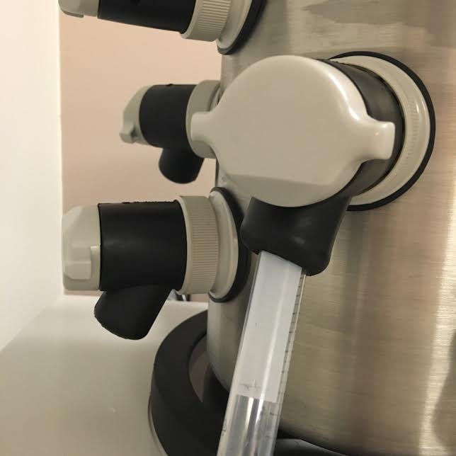

- Watch to make sure the Torr decreases to indicate vacuum is working.
- To check if sample is dry, turn lyophilizer valve so it matches with the circle and releases the vacuum. The pump leaves on
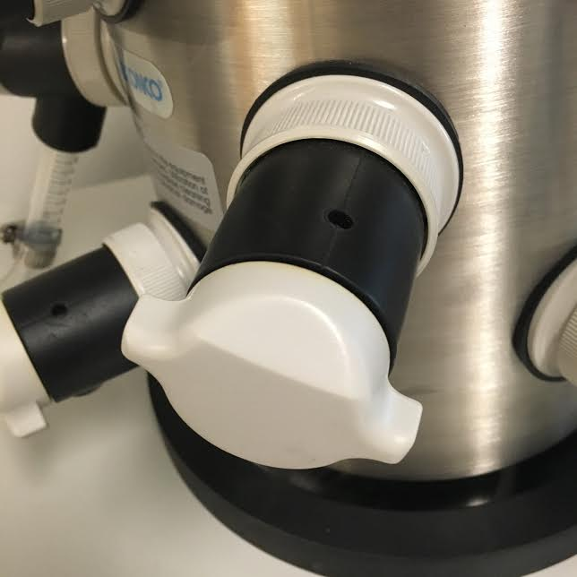

- Turn off Speedvac rotor and wait until it’s at a complete stop before opening Speedvac. If not dried, put in to continue to dry. If not dry for more than one hour, leave the tubes in -80 freezer for >15 min and then put back into the Speedvac. Follow Steps 5-7 to resume the dry.
- After check it is dried, press “vacuum”.
- Shut down: Turn off vacuum pump, press the Vacuum Switch on the control panel to turn the vacuum pump off, press the “Man” to turn off the refrigeration, release the vacuum by turning the valve , Turn off Lyophilizer power button on the left.
- Leave lid ajar

Caution!!!
Utilization of acid requires immediate cleaning and neutralization after defrost.

Do not attempt to chip ice from the collector coil.

Never attempt to start the vacuum pump when there is liquid in the collector chamber.

Maintenance
- Clean lid, gasket and chamber using soft cloth, sponge or chamois and a mild, non-abrasive soap or detergent or water monthly.
- Check oil level of the vacuum pump. It should be between MIN and MAX. If the oil level is less than an inch (25.4 mm) above MIN, add oil to proper level.
- If oil shows cloudiness, particles or discoloration, drain the pump and replace with fresh oil.
- Ballast the pump once a month.
- Completely empty the collector chamber before the next run or before attempting to start the vacuum pump.

