IHC: Processing of mouse eye tissue for immunofluorescence microscopy
Solutions:
4% PFA-1XPBS (40mL)
10 mL 16% PFA
4mL 10x PBS
26 mL Water
-can keep for up to a month, store at 4°C

20% Sucrose (20mL)
5g Sucrose
2.5mL 10x PBS
Bring to 25mL with water
-can keep for up to a month, store at 4°C

o.1% Triton X-100 1xPBS
50ul PBS
450ul water
0.5mL
-Store at RT

Block Buffer 50mL
5 mL 10x PBS
5 mL Goat serum (10% final concentration)
2.5 mL 10% Trition x-100 (0.5% final concentration)
250 10% sodium Azide
*use sterile water to bring volume to 50mL
-Store at 4°C

Antibody (Ab) Dilution
5 mL 10x PBS
2.5 mL Goat serum (10% final concentration)
2.5 mL 10% Trition x-100 (0.5% final concentration)
250 10% sodium Azide
*use sterile water to bring volume to 50mL
-Store at 4°C

Preparing eye cups:
- Remove eye by carefully cutting out or plucking deeply
- Put eye directly into 4%PFA-1xPBS solution for 10 minutes
- Poke hole in eye and remove cornea with microdissection scissors (Figure 1)
- Agitate in 4%PFA-1xPBS for 50 minutes at RT
- Wash with 1X PBS for 5 minutes x3
Cryoprotection:
- Place eye in 20% sucrose-1XPBS in cold room, rocking, for a minimum for 3 hours but preferably overnight
- Incubate in 1:1 solution of 20%sucrose-1x PBS and OCT for 30 mins
- Removed lens (Figure 2) and incubate in 1:1 solution of 20%sucrose-1x PBS for an additional 30 mins
- Place the eye cup in the cryomold facing up and fill mold with OCT
- Gently Squeeze eye to remove air from the eye cup and position eye in the bottom right corner of the mold (Figure 3)
- Look through the cryomold at eye level and make sure the eye is horizontal (Figure 4)
- Freeze in the dry ice/100% ethanol bath by submerging the button of the cryomold into the ice bath (Figure 5)
- Using a box of dry ice, transfer the eye cup to the -80°C for storage
Cutting:
- Mount block on cryostat so that the small side of the rectangle is facing you (Figure 6)
- Cut 30 micron sections until you can see the “C” shape of the eye up and then with a razor blade made a angled cut to removed excess OCT (reduces curling of cut sections) (Figure 7)
- Collect 16 micron section, using cryostat, flatten sections with paint brushes
- Place 3-4 section on a Superfrost+ slide
- Let the slide dry at RT for 1 hour and store slides in -20°C
Staining: Make sure sections do not dry out throughout this process
- Circle section with a pap-pan
- Wash away OCT with 1X PBS for 5 minutes x3
- Block for 1 hr. with blocking buffer at RT in a chamber
- Suck up blocking buffer
- Wipe off slide and reapply pap-pen
- Combine primary antibody with Ab Dilution solution to yield the recommended concentration for the primary antibody
- Apply primary antibody to slide at RT for 2hr-o/n, in a chamber
- Wash for 15 minutes x2 in 0.1%Triton x-100 in 1XPBS in a jar
- Wipe pap-pen off slide and re-apply pap-pen
- Apply secondary antibody the same as primary, add 1ul of DAPI, apply on sections 1 hr, RT in a chamber
- Suck out the Ab
- Wash for 15 minutes x 2 with 0.1%Triton X-100 in1XPBS in a jar
- Dry the slide and apply the mounting media, and place the cover slip. Seal perimeter with clear nail polish

Figure 1: enucleated eye with the cornea removed
Figure 2: enucleated eye with lens removed
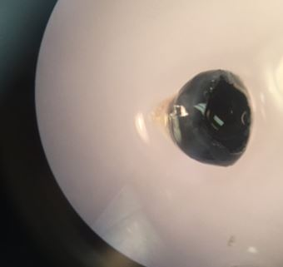

Figure 3: Eye positioned in OCT within cryomold

Figure 4
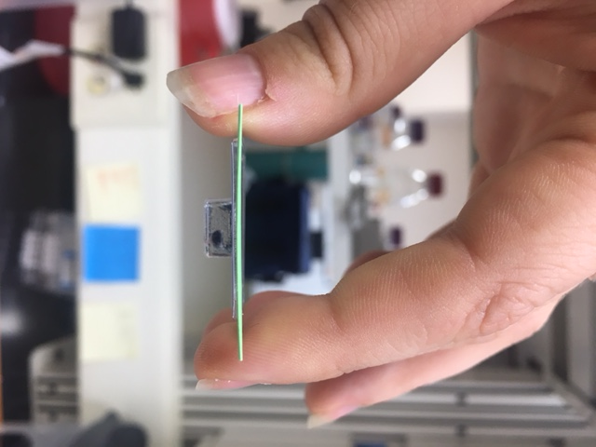

Figure 5: eye cup being frozen in dry ice/ ethanol ice bath
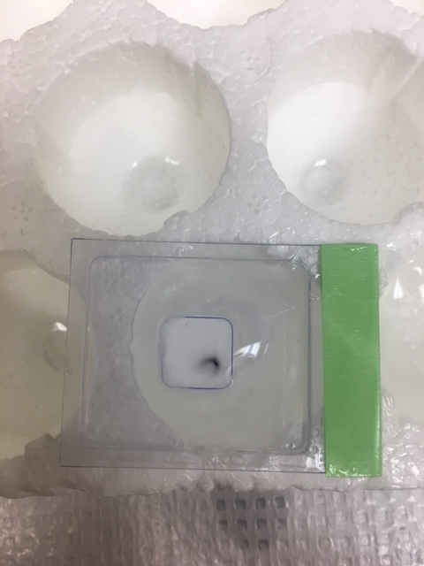

Figure 6: OCT Block Mounted on Cryostat
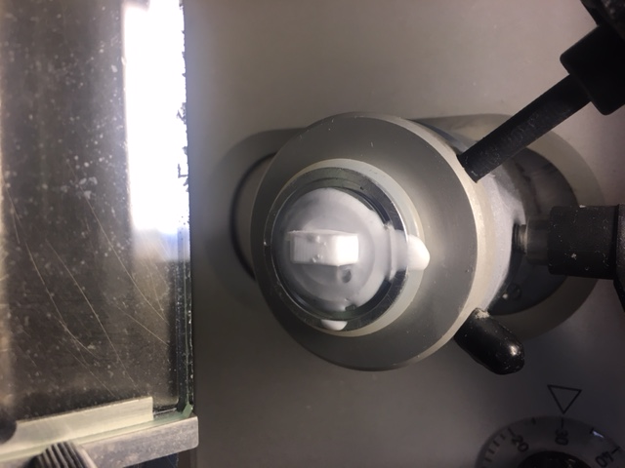

Figure 7
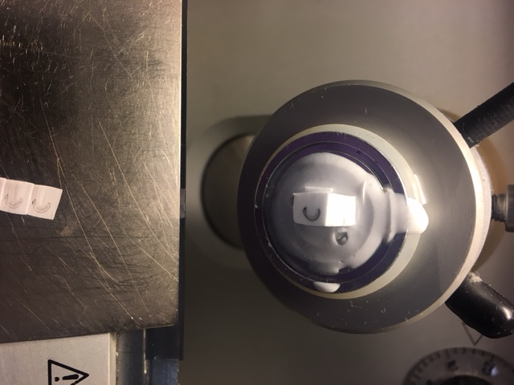

Materials List:
- 16% PFA- Electron Microscopy Sciences (Cat. No. 15710)
- 10x PBS- Research products international (Cat. No. P32060-4000.0)
- Trition X-100- LabChem (Cat. No. LC262801
- Sucrose- Sigma (Cat. No. 84097-1kg)
- Goat Serum- Gibco (Cat. No. 16-210-064)
- Sodium Azide- GFS chemicals (Cat. No.3512)
- Pap pen- Research Products International
- Tissue Tek Cryomold 10mm X 10 mm X 5 mm (Cat. No.4565)
- Tissue Tek O.C.T. compound (Cat. No. 4583)
- Fluromount-G- Sountern Biotech (Cat. No.0100-01)
- Cover slips- Fisher 22x40-1.5 (Cat. No.12-544-B)
- Superfrost Plus Slides 25 X 75 X 1mm (Cat. No. 4951plus-001)
- Clear Nail polish

