Western Blot imaging with Odeyssey LI-COR
- Open Odeyssey, click “Yes”
- Create a document, Click “File”, then “New”
- Click “Browser”
Select： Computer/ Windows C:/ Odyssey, Odyssey_Projects, Jianhai_lab, make a folder with your name,
Make folders for each month
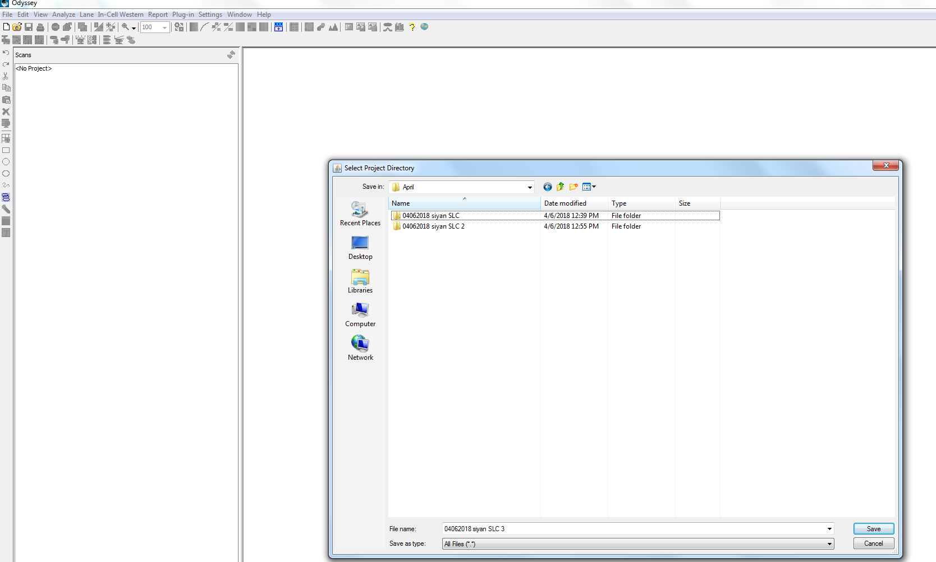
Type the Date, Name, Samples’ information into the File name, then save

- Click the blue arrow, Password: mbrcc
- Open the lid, clean the glass with water and wipe with tissue paper.
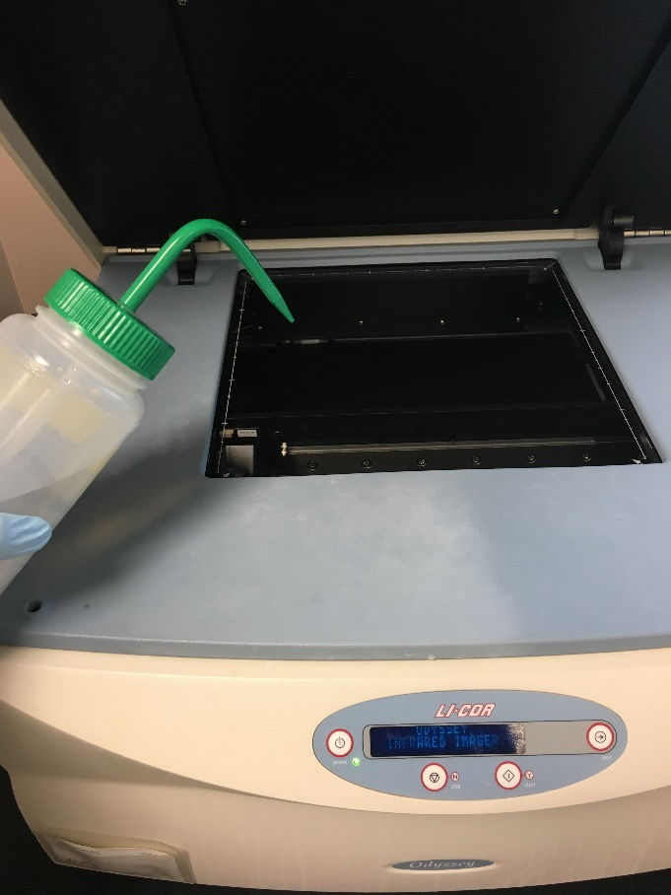

- Put the membrane at the corner (no bubbles, doesn’t matter which side face down)
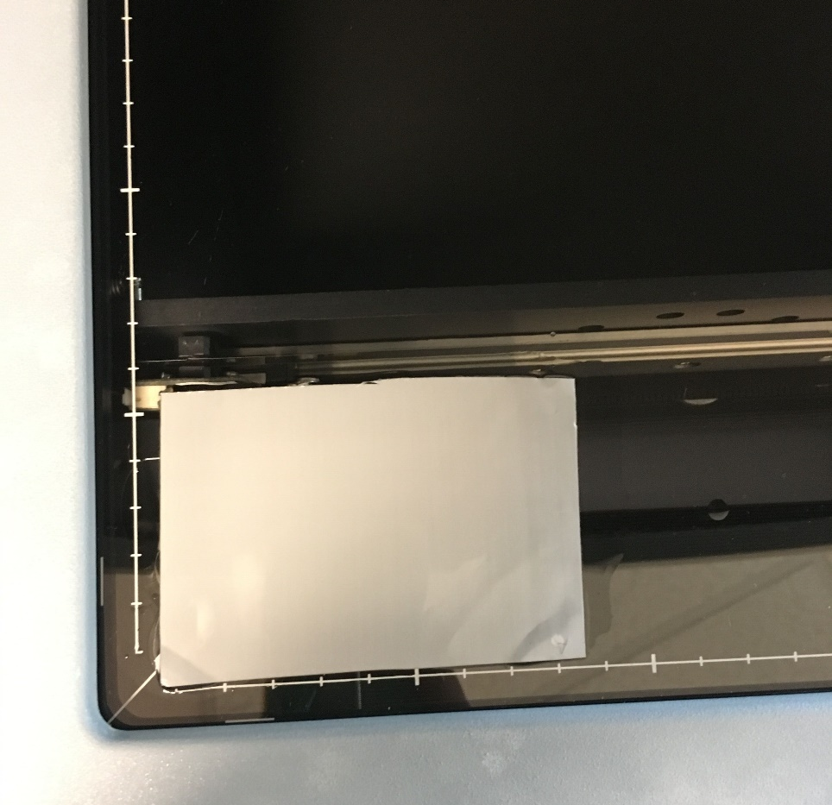
- Check about the x y range, select on the computer for example, 9 x 6
Channels: 700 for red, 800 for green (Based on the second antibody), click “start”
- The original picture has black background and red band. It can be adjusted by Clicking “Alter Image”
Change the brightness and contrast get the clearest picture, display grey image. (Remember all the changes should be linear)
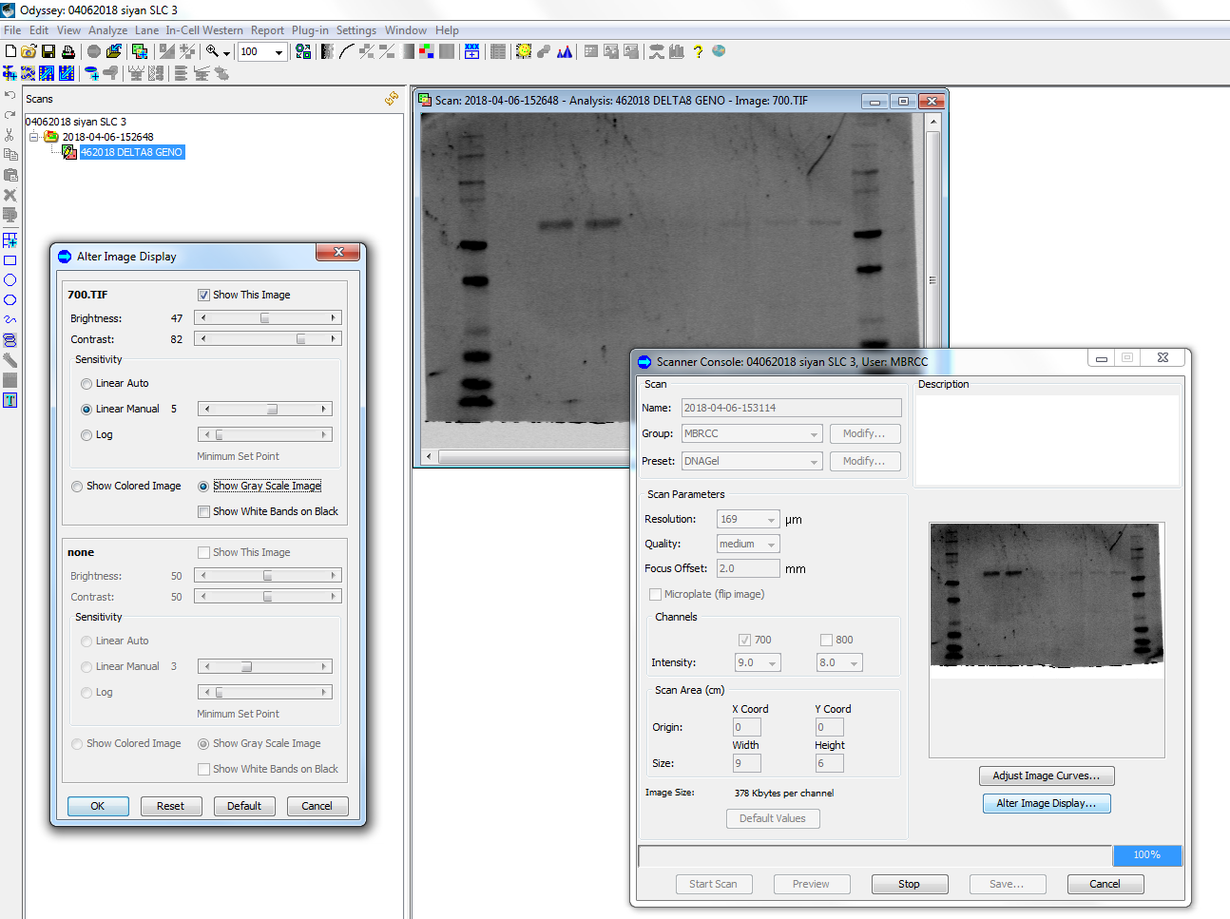

- Use the rectangular shape to detect the grey scale of bands and the amount of the target protein. Write down the number for each sample.
- Always save your image with the highest resolution. Click “File”, Export image, save it as Tiff first.
Export again as High quality JPEG (to report your data).
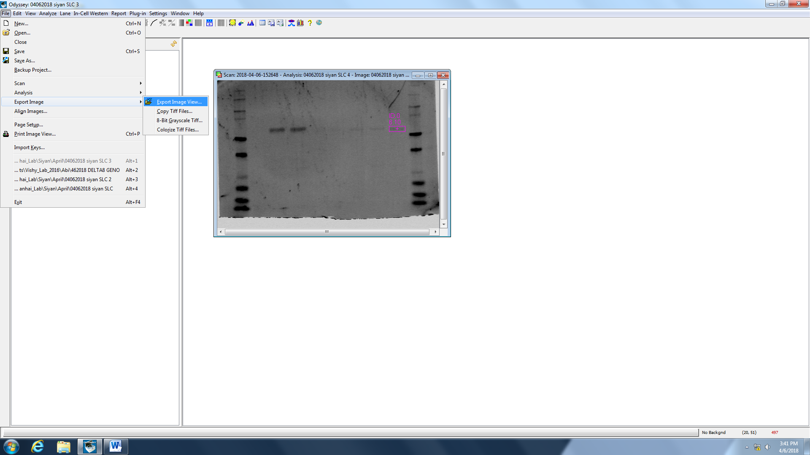
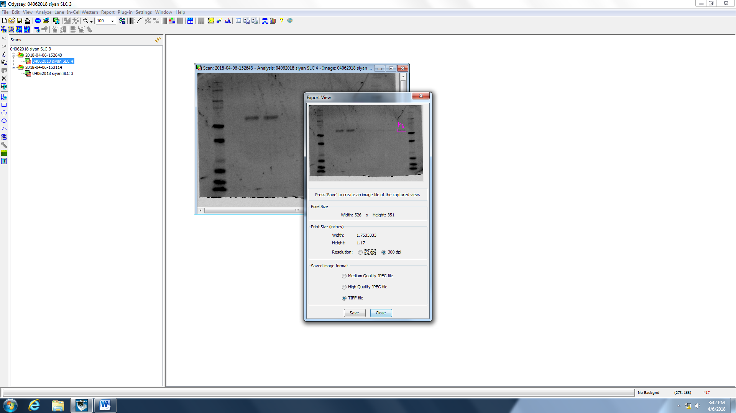
- Save and store the membrane, wipe clean the glass before leaving.
- Save the original picture and make a copy for analysis.

